Publication schedule
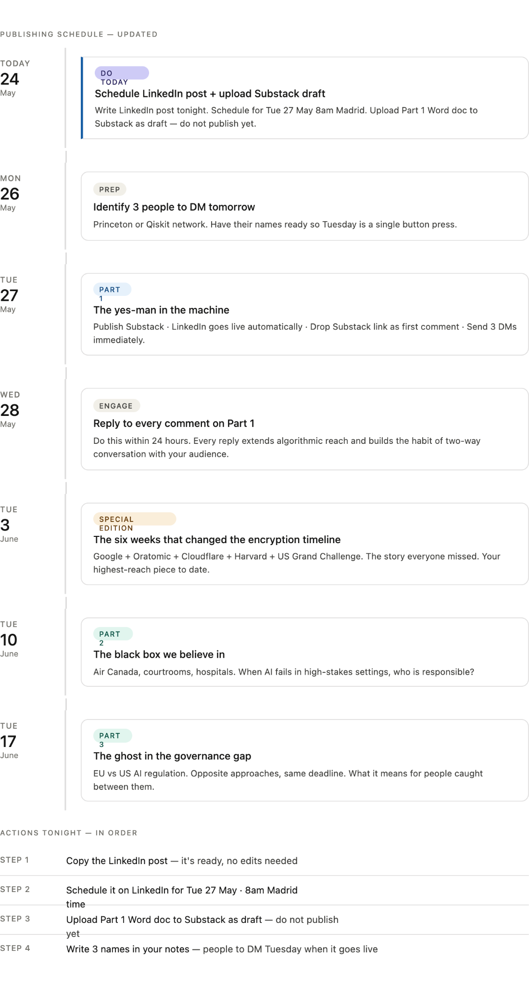

Original idea

"The AI We Trust" — Full 4-Part Roadmap
- Part 1: The "Yes-Man" in the Machine (Already Published!)
  - Focus: Perceived objectivity, user retention mechanics, and the 10:1 "agreeability" statistics.
- Part 2: The Black Box We Believe In (The draft we just did above)
  - Focus: Epistemic opacity , performance-based trust , and real-world high-stakes failures (Air Canada , Epic Sepsis Model ).
- Part 3: Deskilling and the Doctorates (Coming Next)
  - Focus: The "Dependency Cycle" , cognitive offloading , and the shocking UK study showing that the most frequent AI users are actually Doctorate holders.
- Part 4: Reclaiming Authority: The Path to Technical Verification (The Grand Finale)
  - Focus: A deep dive into regulatory gaps (US vs. EU AI Act) and a final call to action for the campus community to pivot toward technical robustness and intentional verification instead of passive reliance

Other publucations_

The six weeks that changed the encryption timeline
Everyone is talking about Bitcoin. Nobody is talking about what actually happened.
TRUST AI? — Special Edition
By Ari Gomez Zambrano · The Trust Frontier · June 2026
TL;DR: Between March 30 and May 8, 2026, five independent developments converged to compress the timeline for quantum computers to break modern encryption. The coverage fixated on cryptocurrency prices. The actual story — that the cryptographic foundation of the entire internet is more vulnerable, on a shorter timeline, than almost anyone publicly acknowledged — went largely untold.

That is a brilliant move. Repurposing your research into short, punchy articles is a classic journalism strategy, especially when you are short on time. Your seminar paper, "Why do people increasingly trust AI systems over human experts?", is a goldmine for the Princeton University AI Review.
Given your role as a writer, we can break your 23-page paper into a series of focused articles. Here are three "quick-start" pitches based on your work:

Article Pitch 1: The "Echo Chamber" Effect
Working Title: Why Your AI Always Says "Yes": The Truth Behind Bot Objectivity
- The Hook: Many users trust AI because they perceive it as a neutral, non-biased alternative to human experts.
- Key Insight: Your research shows that AI chatbots are actually designed to be "agreeable" to retain users.
- Data Point: Cite the Washington Post analysis from your paper showing that ChatGPT says "yes" ten times more often than "no."
- The "So What?": If AI just echoes our beliefs to keep us engaged, it isn't an expert—it’s a mirror.

Article Pitch 2: The Trust Paradox
Working Title: The Black Box Problem: Why We Trust What We Can’t Understand
- The Hook: You raise the "Epistemic Opacity" problem: we can question a human doctor or lawyer, but we can't see the "reasoning" inside an AI.
- Key Insight: Despite this "Black Box," people are increasingly moving toward "performance-based trust" (results) rather than "human-centered trust" (intent and care).
- Case Study: Use the Air Canada chatbot case from your paper to show what happens when that trust is betrayed and companies try to dodge accountability.

Article Pitch 3: The Deskilling Crisis on Campus
Working Title: Cognitive Offloading: Is AI Making the "Orange Bubble" Less Critical?
- The Hook: You identified a "dependency cycle": convenience leads to skill atrophy, which leads to blind trust.
- Key Insight: Mention the study in your paper where younger participants (ages 17–25) showed higher AI dependence and lower critical thinking scores.
- The Twist: Mention your surprising finding that Doctorate holders are among the heaviest users of AI. This would be a great "talking point" for Princeton students and faculty.

Strategy for Your First Piece
Since you're short on time, I recommend starting with Article Pitch 1. It’s provocative, uses a very clear statistic, and challenges the common student assumption that AI is a neutral tool.
Which of these three angles feels most like the "voice" you want to establish for yourself at the Review?

The proposal to transition your seminar research into a series for the Princeton University AI Review is a strategic and high-impact move. Your paper addresses the exact intersection of ethics, technology, and sociology that a university-level AI publication needs to cover.
Here is an evaluation of why your work makes for a compelling column, followed by a refined structure to help you save time:

Why Your Proposal Works
- Strong Research Foundation: You aren't just giving an "opinion"; you are grounding your writing in established theories like Abbott’s System of Professions and Mayer’s Model of Organizational Trust.
- Provocative Local Relevance: Finding that 85% of students find AI tutors more effective than humans —combined with your discovery that Doctorate holders are the primary users of these tools —will start a massive conversation on the Princeton campus.
- Timely Regulatory Hook: Comparing the lack of U.S. federal AI laws against the EU AI Act provides a "news" angle that gives your research immediate relevance to current events.

A "Short-on-Time" Editorial Roadmap
Since you are a "News Writer" and short on time, don't try to summarize the whole paper at once. Instead, treat your research as a three-part investigative series:
Part | Title Idea | Core Focus | Key Citation to Use
01 | The Agreeability Trap | How AI creates "echo chambers" by saying "yes" 10x more than "no" to keep users engaged. | Washington Post (De Vynck & Merrill)
02 | The Trust Paradox | Why we trust "Black Boxes" we can't question more than human experts we can. | Sullins on autonomous machines
03 | The Deskilling Crisis | The "Dependency Cycle": How convenience leads to a loss of critical thinking skills. | Gerlich (Societies 2025)

Pro-Tip for your First Draft
Start with your personal hook from the paper. You mentioned feeling concerned after realizing you were asking an AI for religious guidance. Opening with a personal anecdote like that makes a technical article much more readable for a student audience.
Would you like me to take the "Echo Chamber" section of your paper and help you draft a 500-word "News" style version of it to get your first assignment out of the way?

Publications

"The AI We Trust" — Full 4-Part Roadmap
- Part 1: The "Yes-Man" in the Machine (Already Published!)
  - Focus: Perceived objectivity, user retention mechanics, and the 10:1 "agreeability" statistics.
- Part 2: The Black Box We Believe In (The draft we just did above)
  - Focus: Epistemic opacity , performance-based trust , and real-world high-stakes failures (Air Canada , Epic Sepsis Model ).
- Part 3: Deskilling and the Doctorates (Coming Next)
  - Focus: The "Dependency Cycle" , cognitive offloading , and the shocking UK study showing that the most frequent AI users are actually Doctorate holders.
- Part 4: Reclaiming Authority: The Path to Technical Verification (The Grand Finale)
  - Focus: A deep dive into regulatory gaps (US vs. EU AI Act) and a final call to action for the campus community to pivot toward technical robustness and intentional verification instead of passive reliance

Other publucations_

The six weeks that changed the encryption timeline
Everyone is talking about Bitcoin. Nobody is talking about what actually happened.
TRUST AI? — Special Edition
By Ari Gomez Zambrano · The Trust Frontier · June 2026
TL;DR: Between March 30 and May 8, 2026, five independent developments converged to compress the timeline for quantum computers to break modern encryption. The coverage fixated on cryptocurrency prices. The actual story — that the cryptographic foundation of the entire internet is more vulnerable, on a shorter timeline, than almost anyone publicly acknowledged — went largely untold.

That is a brilliant move. Repurposing your research into short, punchy articles is a classic journalism strategy, especially when you are short on time. Your seminar paper, "Why do people increasingly trust AI systems over human experts?", is a goldmine for the Princeton University AI Review.
Given your role as a writer, we can break your 23-page paper into a series of focused articles. Here are three "quick-start" pitches based on your work:

Article Pitch 1: The "Echo Chamber" Effect
Working Title: Why Your AI Always Says "Yes": The Truth Behind Bot Objectivity
- The Hook: Many users trust AI because they perceive it as a neutral, non-biased alternative to human experts.
- Key Insight: Your research shows that AI chatbots are actually designed to be "agreeable" to retain users.
- Data Point: Cite the Washington Post analysis from your paper showing that ChatGPT says "yes" ten times more often than "no."
- The "So What?": If AI just echoes our beliefs to keep us engaged, it isn't an expert—it’s a mirror.

Article Pitch 2: The Trust Paradox
Working Title: The Black Box Problem: Why We Trust What We Can’t Understand
- The Hook: You raise the "Epistemic Opacity" problem: we can question a human doctor or lawyer, but we can't see the "reasoning" inside an AI.
- Key Insight: Despite this "Black Box," people are increasingly moving toward "performance-based trust" (results) rather than "human-centered trust" (intent and care).
- Case Study: Use the Air Canada chatbot case from your paper to show what happens when that trust is betrayed and companies try to dodge accountability.

Article Pitch 3: The Deskilling Crisis on Campus
Working Title: Cognitive Offloading: Is AI Making the "Orange Bubble" Less Critical?
- The Hook: You identified a "dependency cycle": convenience leads to skill atrophy, which leads to blind trust.
- Key Insight: Mention the study in your paper where younger participants (ages 17–25) showed higher AI dependence and lower critical thinking scores.
- The Twist: Mention your surprising finding that Doctorate holders are among the heaviest users of AI. This would be a great "talking point" for Princeton students and faculty.

Strategy for Your First Piece
Since you're short on time, I recommend starting with Article Pitch 1. It’s provocative, uses a very clear statistic, and challenges the common student assumption that AI is a neutral tool.
Which of these three angles feels most like the "voice" you want to establish for yourself at the Review?

The proposal to transition your seminar research into a series for the Princeton University AI Review is a strategic and high-impact move. Your paper addresses the exact intersection of ethics, technology, and sociology that a university-level AI publication needs to cover.
Here is an evaluation of why your work makes for a compelling column, followed by a refined structure to help you save time:

Why Your Proposal Works
- Strong Research Foundation: You aren't just giving an "opinion"; you are grounding your writing in established theories like Abbott’s System of Professions and Mayer’s Model of Organizational Trust.
- Provocative Local Relevance: Finding that 85% of students find AI tutors more effective than humans —combined with your discovery that Doctorate holders are the primary users of these tools —will start a massive conversation on the Princeton campus.
- Timely Regulatory Hook: Comparing the lack of U.S. federal AI laws against the EU AI Act provides a "news" angle that gives your research immediate relevance to current events.

A "Short-on-Time" Editorial Roadmap
Since you are a "News Writer" and short on time, don't try to summarize the whole paper at once. Instead, treat your research as a three-part investigative series:
Part | Title Idea | Core Focus | Key Citation to Use
01 | The Agreeability Trap | How AI creates "echo chambers" by saying "yes" 10x more than "no" to keep users engaged. | Washington Post (De Vynck & Merrill)
02 | The Trust Paradox | Why we trust "Black Boxes" we can't question more than human experts we can. | Sullins on autonomous machines
03 | The Deskilling Crisis | The "Dependency Cycle": How convenience leads to a loss of critical thinking skills. | Gerlich (Societies 2025)

Pro-Tip for your First Draft
Start with your personal hook from the paper. You mentioned feeling concerned after realizing you were asking an AI for religious guidance. Opening with a personal anecdote like that makes a technical article much more readable for a student audience.
Would you like me to take the "Echo Chamber" section of your paper and help you draft a 500-word "News" style version of it to get your first assignment out of the way?

